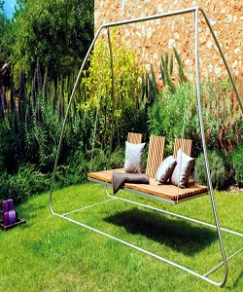

Garden Swing

$75.16

Availability: In stock

**Description:**

Classic look this beige color and silver frame outdoor swing perfectly fits in any style of garden, backyard and garden decor. Stability & safety Heavy duty steel frame and sturdy base ensure stability; high quality and heavy springs make it better safety with a smooth rocking motion. Durable canopy Made from100% Polyester fabric, the adjustable canopy top offers UV and sunlight protection as well as water, fire and weather resistant